FOR IMMEDIATE RELEASE
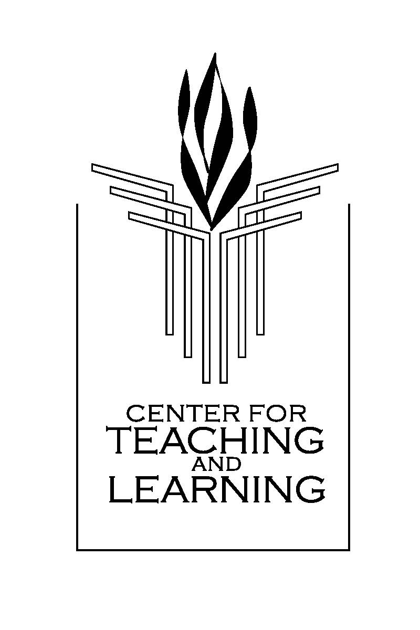
MEDIA INQUIRES: Bruno Tedeschi (908) 591-3631

New Jersey Center for Teaching and Learning to Expand Math and Science Program Nationwide

National Education Association Grant Will Allow CTL to Expand Number of Physics Teachers

TRENTON, N.J. – Oct. 2, 2012 – The New Jersey Center for Teaching and Learning announced plans to expand and replicate its successful math and science program developed in New Jersey throughout the United States thanks to a $500,000 matching grant from the National Education Association.

The NEA grant, announced today, will allow CTL to expand the number of physics and chemistry teachers in other states as well as train current elementary, math and science teachers to be more effective in teaching math and science. In addition to the $500,000 grant, the NEA is has committed to help raise at least $1 million in additional funds.

Founded in 2006 by the New Jersey Education Association, the non-profit CTL has placed an average of 30 new physics teachers into New Jersey public schools each of the last three years. Previously, all of New Jersey’s universities combined only produced an average of 10 new physics teachers per year in the last two years.

“If America is going to remain competitive globally tomorrow, our students today must have a mastery of science and math,” said CTL Executive Director Bob Goodman. “The challenge we face in New Jersey and the rest of the nation is that not enough students are taking rigorous math and science courses, this is especially the case for physics. But before we can even address that problem, we first need to train enough teachers. This grant from the NEA will help us get there much faster.”

CTL developed two programs, the Progressive Science Initiative (PSI) for high school science and the Progressive Mathematics Initiative (PMI) for K-12 mathematics. Each program demystifies math and science education.

PSI corrects the sequence of high school science instruction from biology-chemistry-physics to a mathematically rigorous freshman physics followed by chemistry and biology; a change that is recognized as highly desirable but practically difficult to implement due to a shortage of physics teachers. PSI addresses that obstacle through an innovative approach that creates effective new physics teachers by using the same approaches it developed to teach students.

PMI uses those same approaches to classroom technology, pedagogy, curriculum and assessment that have proven so effective in PSI to teach kindergarten mathematics through AP Calculus. The approach provides a level of grade-to-grade coherence that has not previously been available in math education.

Both PSI and PMI use technology to seamlessly integrate curriculum, pedagogy and assessment, making science and math more accessible while using free open-source digital course content posted at www.njctl.org, to eliminate the need for costly traditional printed textbooks.

PSI has led to a marked increase in the number of students sitting for and passing Advanced Placement science exams, even in urban schools, where high levels of academic performance would not be expected.

Since PSI began at Bergen County Technical High School, nearly 20 times as many students took the AP Physics exam in 2010 than the state average, and more than 85 schools in New Jersey have adopted the program.

Goodman said CTL will identify partners in other states who are interested in achieve the results the program has been able to achieve in New Jersey. CTL’s teacher training program has graduated 115 new physics and chemistry teachers since it began in 2009 and 24 more are currently enrolled. CTL has also provided training for teachers in New York, Colorado, Rhode Island, The Gambia, and Argentina.

